# Persistence of recruitment variability differences among co-occurring North Atlantic groundfish species

# Introduction

Patterns of recruitment and its variability are known to differ substantially among marine fish species, as well as depending on a variety of both intrinsic and extrinsic factors (e.g., Winemiller and Rose 1992, Spencer and Collie 1997, Houde 2016, Petrik et al 2021). Intrinsic factors such as the biomass and physiological condition of the spawning stock play a dominant role in determining recruitment success for many species, primarily those that are long-lived, iteroparous and attain large body sizes. Age and size structure, and the diversity of age structure, also play important roles in recruitment success given the demonstrated survival advantage that offspring from older, repeat spawners have over first time, smaller parents (Marshall 2016). Extrinsic factors involving environmental variability can influence recruitment success, more commonly among small bodied, semelparous, short lived species but can become more influential among larger-bodied species when exploitation effects cause a truncation of age structure and/or a reduction in stock biomass or body size. Recruitment and its relationship with the environment can therefore change over time, not only due to environmental changes but also due to phenotypic changes within the stock itself (Myers 1998; Brosset et al. 2020).

Some of the most perplexing patterns exist when seemingly closely related, sympatric species with similar life histories exhibit differential recruitment success and recruitment variability. Atlantic cod (*Gadus morhua*) and haddock (*Melanogrammus aeglefinus*) are gadoids found in shelf and coastal ecosystems in the western and eastern North Atlantic. The species have similar habitat requirements and overlap geographically, although cod extends further north and into colder waters on both sides of the Atlantic. Cod and haddock sustain large fisheries, often targeting both species in areas where they co-occur. Most stocks of these species have been overexploited historically. During the early 1990s, the cod and haddock fishery in the Northwest Atlantic collapsed, with landings less than 10% of historic maxima.

The decline of cod and haddock stocks motivated Fogarty et al (2001) to study the two species’ resilience to over-exploitation and their capacity for recovery from depletion, through a comparative analysis of the species reproductive capacity. Their study involved a comparative analysis of sympatric cod and haddock stocks in eight regions across the North Atlantic focusing on the quantification of recruitment variability and other reproductive parameters generated from theoretical stock and recruitment relationships. They found that haddock stocks exhibited consistently higher variability and lower reproductive rates compared to cod stocks in all of the geographic regions considered. This led the authors to conclude that cod have a higher resilience to overexploitation, but that depleted haddock stocks might be rescued by chance recruitments events and recover if strong year classes were protected from excessive exploitation.

Since Fogarty et al. (2001), the shelf ecosystems in the North Atlantic have changed and, in some instances, quite dramatically. These changes could have altered the patterns of recruitment variability and resilience to overfishing established by Fogarty et al (2001), Large-scale environmental warming trends have occurred in the shelf seas in the North Atlantic, with accelerated warming in the most recent decades (Garcia-Soto et al 2021). In the western Atlantic, fishing moratoria were introduced following stock collapses. These collapses were accompanied by ecosystem regime shifts and trophic cascades delaying or preventing stock recovery by altering trophic structure (Frank et al 2005). In the eastern Atlantic, the northernmost stocks located in the Barents Sea, have increased rapidly following reduction in fishing pressure and reached record high biomass levels.

Alongside the ecosystem changes, demographic structure of many cod and haddock stocks has changed. For instance, condition and size-at-age of cod and haddock on Scotian shelf has declined since the mid 1990’s and has remained low since then (Shackell and Frank 2007, Shackell et al 2010). In North Sea cod and haddock size and maturity at age has also declined (Baudron et al 2011, 2014, Marty et al 2014), and similar but not as dramatic declines in size and maturity at age have been observed for Icelandic cod (e.g. Pardoe et al 2009).

These well documented changes to the trophic structure, management regimes, and stock characteristics (spatial distributions, maturity, size and conditions at age), occurring in a warming ocean, may all impact recruitment variability of both cod and haddock, but not necessarily to the same extent or in the same direction throughout their range (Klein et al 2016, Fogarty et al 2008, Mantzouni et al 2010).

Here we update and extend the analysis conducted by Fogarty et al. (2001) utilizing model output from recent stock assessments to determine if the recruitment variability and reproductive rate differences among co-occurring North Atlantic cod and haddock have persisted. We divided the analysis into two periods – before and after 1993 with the former corresponding to the time period studied by Fogarty et al. (2001) and the latter associated with changes in the ecosystems, management regimes, stock characteristics and accelerated warming.

# Methods

## Data

We compiled time series of recruitment (R) and spawning stock biomass (SSB) of sympatric cod and haddock stocks from recently available, age-structured assessments conducted by the International Exploration of the Seas (ICES), Fisheries and Oceans Canada (DFO) and the National Marine Fisheries Service (NMFS). These stock pairs were from the same geographic areas that were evaluated by Fogarty et al (2001); we also added one additional area - the Irish Sea (Table 1). The West of Scotland region which was part of the original analysis by Fogarty et al. (2001) was excluded from our analysis, since haddock West of Scotland is no longer assessed as a separate stock, but instead is now assessed as part of the larger North Sea stock.

The ICES advice web site (<https://www.ices.dk/advice/Pages/Latest-Advice.aspx>), was used to access recruitment and SSB model output for the Northeast (NE) Atlantic stocks for 2021with the exception of the Faroese stock, which was last assessed in 2020. Regional stock and recruitment data for the Northwest (NW) Atlantic stocks of cod were obtained from the following sources: Eastern Scotian Shelf: Div. 4VsW (Mohn and Swain 2012), Western Scotian Shelf: Div. 4X5Y (DFO 2019), Eastern Georges Bank (Wang et al. 2015). For the NW Atlantic stocks of haddock the sources were: Eastern Scotian Shelf: Div. 4VW (Mohn and Simon 2002), Western Scotian Shelf: Div. 4X5Y (Wang et al. 2017), Eastern Georges Bank (Stone et al. 2015). The cod and haddock stocks resident on the Eastern Scotian Shelf (Div. 4VW) collapsed in the earlier 1990s. They were placed under a moratorium and are no longer regularly assessed (Table 1), despite supporting large scale fisheries in the past and showing recent improvements in biomass.

In this analysis we focus on within region comparisons of the cod and haddock stocks (Table 1). The age at recruitment differs among regions and in some cases, age at recruitment differs within species within regions. Fogarty et al (2001) standardized recruitment of all stocks to age 1, but because we focused only on within region comparisons, the stocks were standardized within regions when age at recruitment differed (see Table 1).

## 

## Analysis

Following the same approach as Fogarty et al (2001), recruitment variability was assessed using a Ricker stock and recruitment model (Supplement Figure S1 and S2). The Ricker model was linearized to:

$$log(\frac{R}{SSB})=log(a)+b×log(SSB)+ϵ_{i})$$

where *R* is the number of recruits and *SSB* is the spawning stock biomass in the birth year of the recruits. The parameter *a* is the intercept of the relationship on a log scale and is commonly referred to as the steepness parameter which provides an estimate of the number of recruits produced at low *SSB*. The parameter *b* controls the location of the inflection point of the Ricker model and the error term in the model is represented by $ϵ_{i}$, which we have assumed to be normally distributed. The standard deviation of the residuals from this model was used as one of our metrics of recruitment variability.

Given that there may be a great deal of uncertainty in the fitting of theoretical stock and recruitment relationships to data, we also quantified recruitment variability based on a *model-free* approach using Generalized Additive Models (GAMS) which served to remove trends, potentially resulting from SSB, from the recruitment time series (on the log scale) for each stock (Supplement Figure S3). The standard deviation of the residuals from this *model-free* approach were used as a second metric of recruitment variability for each stock.

We chose to separate the analysis of the SSB and R time series into two periods to facilitate a comparison with the results obtained by Fogarty et al. (2001) and to assess the possibility that there were differences in the observed patterns during the most recent time period. Hence, the time series were split into a “*Pre 1993”* (years prior to and including 1992) period and a “*Recent”* period (1993-end of time series). In addition to facilitating a direct comparison with Fogarty et al. (2001), the early 1990s marked a point in time when many of the NW Atlantic stocks of cod and haddock either collapsed or reached a historical minimum (Shackell and Frank 2007, Frank et al. 2016).

The steepness parameter in the Ricker stock and recruitment model (e.g. Wiff et 2018, Lowerre-Barbieri et al 2017) is an estimate of the number of recruits produced per unit SSB at low SSB levels. It is considered an indicator of a stock’s ability to recover from collapse/depletion and was evaluated for each stock. Because of our concerns regarding the fitting of theoretical models to our data, we have also estimated steepness directly from the data by calculating the average R/SSB at low SSB levels where low SSB values were considered to be 40% of the maximum SSB value in the time series.

We also quantified temporal autocorrelation in the recruitment residuals from both the Ricker and GAM models in keeping with the various lines of inquiry initiated by Fogarty et al. (2001). The existence of significant negative autocorrelation implies inter-cohort intraspecific competition and/or cannibalism, whereas positive autocorrelation suggests persistent environmental forcing may be operative (Ricard et al 2016). This analysis was conducted to determine if there were species-specific patterns that would explain difference in the magnitude of residual variability between the two species.

Finally, we estimated the temporal correlation of the recruitment residuals between cod and haddock stocks within each region in each period. A positive correlation may imply that the two species are responding to environmental drivers in the same way whereas a negative correlation would suggest that interspecific competition, predation or that environmental drivers act to produce contrasting species-specific effects. Finally, we investigated whether or not the correlation between recruitment of sympatric stocks changed over time (e.g., Bogstad et al. 2013 found this to be the case for Barents Sea cod and haddock). Significant differences in the correlation of the recruitment residuals between the stocks in each period would be indicative of such a shift.

# Results

**Input data**

The SSB and R time series were generally longer for the NE Atlantic stocks in comparison to the available data for the NW Atlantic stocks, attributable in part to earlier start time of the NE series (Table 1). The year SSB reached its minimum observed level did not show any particular pattern with the possible exception of three regions (Iceland, Barents Sea, and North Sea) where minima occurred prior to the 1990s (with the exception of North Sea cod). There was no pattern in the year of maximum SSB which ranged as early as 1955 for Icelandic cod to 2013 for cod and haddock in the Barents Sea and 2018 for Irish Sea haddock. Variability in SSB, based on the ratio of the maximum to minimum observed values in the time series, was lowest among the NE Atlantic haddock stocks (range: 4.4 – 10.7), followed by NE cod stocks (range: 6.3 – 20.9), NW Atlantic haddock stocks (range: 3.1 – 25.2) and NW cod stocks (range: 10 - 39). Myers and Barrowman (1996) have argued that poor fits of theoretical stock and recruitment relationships often arise due to the low dynamic range of observations so one might expect that relatively stronger S-R relationships will be evident among the NW Atlantic stocks. The Ricker models explained only 27% of the variance between recruits and SSB on average, with no significant difference observed between the species, regions, or period (Table 2).

In nearly every region, the standard deviation of the log10 transformed recruitment series was higher for haddock than for cod (Table 1) suggesting the patterns were robust to the varying time series length and range of variation in SSB. The pattern is also broadly supportive of the finding by Fogarty et al. (2001) regarding higher recruitment variability among co-occurring stocks of haddock and cod, although no adjustments were made to account for the potential influence of spawning stock biomass differences among the two species with regions.

**R and SSB time trends**

For cod across all regions, the recruit numbers in the Recent period were on average 58% lower than the Pre-1993 period, in the NE Atlantic the decline was 49% while in the NW Atlantic this decline was much greater with declines in recruit numbers averaging 73% (Figures 1 - 3). Similarly, the SSB for cod declined in the Recent period by 35% across all regions, which was again driven by the Northwest Atlantic stocks where declines in SSB averaged 72% in the Recent period, the declines for the Northeast Atlantic stocks averaged 13% (Figures 1 - 3).

For haddock across all regions, the recruit numbers increased in the Recent period by 50% relative to the Pre-1993 period, in the Northeast Atlantic there was no difference in the average recruitment numbers between the two periods, while in the Northwest Atlantic the recruit numbers averaged 110% higher in the Recent period (Figures 1 - 3). Similarly, the SSB for haddock increased in the Recent period by 20%, with the increase in SSB higher for the Northwest Atlantic stocks (40%) than the Northeast Atlantic stocks (10%).

**Recruitment residuals**

The results of the analysis using the standard deviation of the recruitment residuals from the Ricker Stock Recruitment models and the GAM models both indicated that recruitment variability was larger for haddock than for cod (Table 2). The standard deviation of the recruitment residuals were on average 80% higher (Ricker model residuals) for the haddock Stocks in the Pre-1993 period than for the cod stocks (Figures 4, 5, and Table 2). In the *Recent* Period, the standard deviation of the recruitment residuals were on average 70% higher (Ricker model residuals) for the haddock Stocks than for the cod stocks (Figures 4, 5,and Table 2), similar to the Pre-1993 period.

**Resilience: Steepness parameter**

In the Pre-1993 period, no general patterns were observed between the steepness parameter estimate (i.e. slope at origin, *log(a)* parameter in Ricker model) of haddock and cod stocks using either the Ricker model estimates (Figure 6 and Table 2) or when using the average log(R/SSB) when SSB is < 0.4 (Figure 7). In the Recent period, the steepness parameter estimates of haddock stocks tended to be higher than the cod stocks using both the Ricker model estimates (Figure 6 and Table 2) and when using the average log(R/SSB) when SSB is < 0.4 (Figure 7). In most cases the steepness estimates in the Recent period were not significantly different, but for all regions except the Eastern Scotian Shelf the steepness estimate was higher for haddock than for cod. These results are in contrast to the results of Fogarty et al. (2001) in which the steepness parameter estimate tended to be higher for cod than observed for haddock.

## Residual Autocorrelation and Time series correlation

The autocorrelation in recruitment residuals in the Pre-1993 tended to be positive for the Northeast Atlantic stocks (Figures 8 and 9). In the Northwest Atlantic, the more southern stocks tended to have a lower autocorrelation, with Eastern Georges Bank cod being the only stock in the analysis with negative residuals using both the GAM model and the Ricker model. The correlation between the cod and haddock stocks tended to be positive in the Pre-1993 period, but for most (4) regions the correlation was not significant (Figure 10). These results are broadly similar to the results found in Fogarty et al. (2001).

The autocorrelation in recruitment residuals in the Recent period tended to be positive for the NE Atlantic stocks (Figures 8 and 9), similar to what was observed in the Pre-1993 period. In the NW Atlantic, the Eastern Georges Bank and Western Scotian Shelf stocks tended to be more negative and had larger uncertainties than most other stocks for both the GAM and Ricker residuals. The correlation between the cod and haddock stocks tended to be positive in the Recent period, but for most (6) regions the correlation was not significant (Figure 10).

# Discussion

Our results confirmed those obtained by Fogarty et al (2001) of higher recruitment variability of haddock compared to cod, both before and after 1993. In contrast, we could not confirm their results on the steepness parameter pattern, since we did not find that cod produced more recruits per unit SSB at low SSB levels. Instead, we found a tendency for increased steepness of haddock compared to cod for the period from 1993 and onwards.

Our estimates of first order autocorrelation recruitment residuals were mostly weak and positive, similar to that of Fogarty et al (2001) and that of Ricard et al (2016), suggestive of similar environmental forcing from year to year. The correlations between recruitment series for sympatric cod and haddock stocks were also mainly non-significant and positive implying that within the same ecosystem, the environmental conditions had a similar (weak) effect on cod and haddock recruitment. Covariation in recruitment among species is not uncommon in the marine environment (Myers et al. 1997). For instance, in the Barents Sea, strong year classes of different species do coincide but tend to do so only in warm years (e.g. Dingsør et al 2007, Landa et al 2014). However, the effect of environmental drivers on recruitment is rarely stationary (Hidalgo et al 2012, Brosset et al 2020). In the Barents Sea during the recent anomalous warm years, the effect of temperature has become less important and the correlation between cod and haddock recruitment has weakened (this study, and Bogstad et al 2013).

Using steepness as a measure of reproductive resilience, we found that overall haddock were as resilient as cod (Pre-1993), or possibly more resilient than cod (Recent period). This is a surprising result since we expected the pre-1993 period to yield higher resilience for cod than haddock as found by Fogarty et al. (2001). However, the input data we used was different from that used by Fogarty et al (2001) a direct comparison was not possible since the most of the original data was no longer available. Stock assessment models do change considerably over time and can render changes in historical series of SSB and R as new and revised data are added. Notably, there are now more sophisticated methods for estimating mortality, e.g. discard mortality of juvenile haddock in the North Sea and Irish Sea (ICES 2021 a,b) and its inclusion can cause an increase in the ratio of recruits per spawner.

We hypothesize that haddock’s greater resilience since 1993 is partly because warming trends benefit haddock more so than cod. Haddock has been found to perform physiologically better than cod in warmer conditions (Norin et al. 2019). The geographic distribution of exploited haddock stocks in western Atlantic does not extend as far north as the cod stocks. In the eastern Atlantic, the Barents Sea is the northernmost distribution range of both species, and there cod extend further north than haddock (ICES 2020 wgibar). In the Irish Sea, in the southern edge of the range of cod and haddock, haddock and whiting (*Merlangius merlangus*) have overtaken the former dominant role of cod (Elliot et al 2018). Cod recruitment is predicted to decline with warming at the southernmost distribution range (e.g. Fogarty et al 2008). Overall, there are fewer studies on the impact of warming on haddock compared to cod (Klein et al 2016), but somewhat less negative warming impact on haddock reproduction compared to cod has been reported (Klein et al 2016). The most compelling evidence is an unpublished study comparing the role of temperature on steepness of cod and haddock (Mantzouni and MacKenzie 2009), revealing an overall positive temperature effect of haddock steepness, whereas for cod the impact was dome shaped.HOW CAN THIS BE STATED IF IT IS AN UNPUBLISHED/ UNREVIEWED DOCUMENT A study comparing the impact of temperature on steepness across all cod stocks found that temperature was negative for steepness in temperatures above 5°C (Mantzouni et al 2010). No comparable study has been conducted across haddock stocks.

In addition to warming, it is possible that a change in life history of haddock has resulted in changes in steepness. Wiff et al (2018) examined the relationship between steepness and life history parameters in 42 demersal and pelagic species. They found that steepness was related to length at maturity relative to the maximum length. Species that matured at shorter lengths relative to their maximum possible lengths, were more resilient. The changes in steepness observed here, compared to Fogarty et al (2001) may be related to changes in growth rate and length at maturity among many of the stocks. The relationship between steepness and life history parameters in haddock and cod stocks deserves further research.

Difference in recruitment variability of closely related species inhabiting the same area is not unique to cod and haddock. A similar pattern had been found for Grand Bank flatfishes and has been attributed to differences in spawning habitat (Walsh et al 2004). However, it is unclear if such a difference exists across the ecosystems where cod and haddock are co-located.

Traits related to recruitment, include both fixed and variable traits that are responsive to changes in the environment over time (Lowerre-Barbieri et al 2017). We found that despite substantial and ongoing changes in the environment, our results confirmed the finding by Fogarty et al (2001) of the higher recruitment variability of haddock compared to cod. Likely therefore, there are fixed traits related to recruitment that vary between the two species rendering haddock more prone to recruitment variability.

Cod and haddock share many reproductive traits with each other, as well as other gadoids and also most other important commercial temperate water species: small pelagic eggs, larvae and early-stage juveniles, high egg production (Lowerre-Barbieri et al 2017) and batch spawning (Murua and Saborido-Rey 2003). Combined with a broad age structure with several reproductive age groups, these traits serve to buffer against environmental perturbation and, up to a point, against perturbations caused by fishing. Cod and haddock also share traits that have been used to classify fish species according to their susceptibility to overfishing, population dynamics and recruitment variability (e.g. Winemiller and Rose 1992). The outstanding question of what accounts for the differences in recruitment variability between cod and haddock remain to be determined. It is often difficult to determine if reported differences among cod and haddock are due to species-specific traits or pertain only to the specific areas studied. For instance, Fogarty et al (2001) reported a more protracted spawning season and broader spatial extent of cod compared to haddock as an explanation of the difference in recruitment variability, but the evidence that exists from the Barents Sea suggests an opposite pattern (Bergstad et al 1987).

Traits that appear to be consistently different between species across areas are diet and maximum size. Adult haddock is more of a benthivore feeding on invertebrates such a brittle stars and polychaetes (Tam et al 2016) compared to cod, which is much more piscivorous and is prone to eating its own young (Link et al 2009). The cannibalistic behaviour can cause density dependence, that potentially stabilizes recruitment, by dampening the production of strong year classes before they reach fishable size. However, the degree of cod cannibalism varies substantially among ecosystems (Link et al 2009) and is unlikely to be important in areas where older, large cod have recently become rare, such as in the Northwest Atlantic stocks examined herein. The buffering of recruitment variability caused by traits related to body size of spawners (longer spawning season, more batches, larger and more eggs) are also likely to be reduced in areas where cod (and haddock) size has been severely depleted, and therefore not likely to explain the consistent pattern in recruitment variability. THERE IS LOTS OF INFORMATION ON SIZE AT AGE FOR COD AND HADDOCK

What type of traits are typically fixed in a species and influence recruitment variability? Small differences in mortality of early life stages create large differences in year class strength. Could the relevant traits responsible for the recruitment variability difference in cod and haddock account for differences in egg and larvae mortality? Haddock eggshell (chorion) is sticky, this attribute has been used to differentiate between early stage eggs of cod and haddock (N: Mukhina pers comm). This chorion characteristic binds oil droplets, enhancing exposure to toxic compounds (Sørhus et al 2015), but probably also has some unknown adaptive significance that may impact recruitment variability, and in some circumstances increase recruitment success. Haddock larvae develop larger pectoral fins earlier than, improving their manoeuvrability (Auditore et al 1994, Petrik et al 2013), which might be of benefit under some instances but might also infer a cost. Despite cod and haddock having large economic, cultural and ecological importance, and over 100 years scientific scrutiny, there are many aspects of their basic biology, including their evolutionary history (Malmstöm et al 2017, Roa-Varón et al 2021), that is poorly understood. Better understanding basic biology and of the evolvability of their reproductive traits will be needed to meet management needs under continuous climate warming.

# References

Auditore PJ, Lough RG, Broughton EA (1994) A review of the comparative development of Atlantic cod (Gadus morhuaL.) and haddock (Melanogrammus aeglefinus L.) based on an illustrated series of larvae and juveniles from GeorgesBank. NAFO Sci Counc Stud 20:7–18

Baudron, A.R., Needle, C.L. & Marshall, C.T. (2011) Implications of a warming North Sea for the growth of haddock Melanogrammus aeglefinus. *Journal of Fish Biology,* **78,** 1874-1889.

Baudron, A.R., Needle, C.L., Rijnsdorp, A.D. & Marshall, C.T. (2014) Warming temperatures and smaller body sizes: synchronous changes in growth of North Sea fishes. *Global Change Biology,* **20,** 1023-1031.

Bergstad, O.A., Jørgensen, T. & Dragesund, O. (1987) Life hstory and ecology of the gadoid resources of the Barents Sea. *Fishereis Research,* **5,** 119-181.

Bogstad, B., Dingsor, G.E., Ingvaldsen, R.B. & Gjosaeter, H. (2013) Changes in the relationship between sea temperature and recruitment of cod, haddock and herring in the Barents Sea. *Marine Biology Research,* **9,** 895-907.

Brosset, P., Smith, A.D., Plourde, S., Castonguay, M., Lehoux, C. & Van Beveren, E. (2020) A fine-scale multi-step approach to understand fish recruitment variability. *Scientific Reports,* **10,** 16064.

Houde E.D. (2016) Recruitment variability. *Fish Reproductive Biology: Implications for Assessment and Management* (eds Jakobsen T., Fogarty M.J., Megrey. B.A. & Moksness. E.), pp. 98-186.John Wiley & Sons Ltd.

DFO. 2019. Stock Assessment of Atlantic Cod (*Gadus morhua*) in NAFO Divisions 4X5Y. DFO Can. Sci. Advis. Sec. Sci. Advis. Rep. 2019/015.

Dingsør, G.E., Ciannelli, L., Chan, K.S., Ottersen, G. & Stenseth, N.C. (2007) Density dependence and density independence during the early life stages of four marine fish stocks. *Ecology,* **88,** 625-634.

Elliott, S.A.M., Allan, B.A., Turrell, W.R., Heath, M.R. & Bailey, D.M. (2018) Survival of the fittest: Explanations for gadoid imbalance in heavily fished seas. *Aquatic Conservation: Marine and Freshwater Ecosystems,* **28,** 1192-1199.

Fogarty, M., Incze, L., Hayhoe, K., Mountain, D. & Manning, J. (2008) Potential climate change impacts on cod (Gadus morhua) off the northeastern USA. *Mitigation and Adaptation Strategies for Global Change,* **13,** 453-466.

Fogarty, M.J., Myers, R.A. & Bowen, K.G. (2001) Recruitment of cod and haddock in the North Atlantic: a comparative analysis. *Ices Journal of Marine Science,* **58,** 952-961.

Frank, K.T., Petrie, B., Choi, J.S. and Leggett, W.C. (2005) Trophic cascades in a fromely cod-dominated ecosystem. *Science,* **308,** 1621-1623.

Frank, K.T., Petrie, B., Leggett, WC, and Boyce, DB. 2016. Large scale, synchronous variability of marine fish populations driven by commercial exploitation. Proc. Natl. Acad. Sci. US 113(29): 8248-8253.

Garcia-Soto, C., Cheng, L., Caesar, L., Schmidtko, S., Jewett, E., Cheripka, A., Rigor, I., Caballero, A., Chiba, S., Báez, J., Zielinski, T. & Abraham, J. (2021) An Overview of Ocean Climate Change Indicators: Sea Surface Temperature, Ocean Heat Content, Ocean pH, Dissolved Oxygen Concentration, Arctic Sea Ice Extent, Thickness and Volume, Sea Level and Strength of the AMOC (Atlantic Meridional Overturning Circulation). *Front.iers in Marine Science,* **8:642372.**

Murua H. . & Saborid-Rey.-F. (2003) Female Reproductive Strategies of Marine Fish Species of the North Atlantic. *Journal of Northwest Atlantic Fisheries Science,* **33,** 23-31.

Hidalgo, M., Gusdal, Y., Dingsør, G.E., Hjermann, D., Ottersen, G., Stige, L.C., Melsom, A. & Stenseth, N.C. (2012) A combination of hydrodynamical and statistical modelling reveals non-stationary climate effects on fish larvae distributions. *Proceedings of the Royal Society B: Biological Sciences,* **279,** 275-283.

ICES (2021a) Working Group for the Celtic Seas Ecoregion (WGCSE). ICES Scientific Reports. pp. 1082.

ICES (2021b) Working Group on the Assessment of Demersal Stocks in the North Sea and Skagerrak (WGNSSK). ICES Scientific Reports. pp. 988 pp.

Johannesen, E., Yoccoz, N.G., Tveraa, T., Shackell, N.L., Ellingsen, K.E., Dolgov, A.V. & Frank, K.T. (2020) Resource-driven colonization by cod in a high Arctic food web. *Ecology and Evolution,* **10,** 14272-14281.

Klein, E.S., Smith, S.L. & Kritzer, J.P. (2017) Effects of climate change on four New England groundfish species. *Reviews in Fish Biology and Fisheries,* **27,** 317-338.

Landa, C.S., Ottersen, G., Sundby, S., Dingsor, G.E. & Stiansen, J.E. (2014) Recruitment, distribution boundary and habitat temperature of an arcto-boreal gadoid in a climatically changing environment: a case study on Northeast Arctic haddock (Melanogrammus aeglefinus). *Fisheries Oceanography,* **23,** 506-520.

Link, J.S., Bogstad, B., Sparholt, H. & Lilly, G.R. (2009) Trophic role of cod in the ecosystem. *Fish and Fisheries,* **10,** 58-87.

Lowerre-Barbieri, S., DeCelles, G., Pepin, P., Catalán, I.A., Muhling, B., Erisman, B., Cadrin, S.X., Alós, J., Ospina-Alvarez, A., Stachura, M.M., Tringali, M.D., Burnsed, S.W. & Paris, C.B. (2017) Reproductive resilience: a paradigm shift in understanding spawner-recruit systems in exploited marine fish. *Fish and Fisheries,* **18,** 285-312.

Malmstrøm, M., Matschiner, M., Tørresen, O.K., Star, B., Snipen, L.G., Hansen, T.F., Baalsrud, H.T., Nederbragt, A.J., Hanel, R., Salzburger, W., Stenseth, N.C., Jakobsen, K.S. & Jentoft, S. (2016) Evolution of the immune system influences speciation rates in teleost fishes. *Nature Genetics,* **48,** 1204-1210.

Mantzouni, I. & MacKenzie, B.R. (2009) Why is haddock overtaking cod? Comparing the effects of temperature and habitat size on both species recruitment dynamics across the N. Atlantic. *ICES CM/3*.

Mantzouni, I., Sørensen, H., O'Hara, R.B. & MacKenzie, B.R. (2010) Hierarchical modelling of temperature and habitat size effects on population dynamics of North cod. *Ices Journal of Marine Science,* **67,** 833-855.

Marshall, T.C. (2009). Implementing information on stock reproductive potential in fisheries management: the motivation, challenges, and opportunities. In T. Jacobsen, M.J. Fogarty, B.A. Megrey, and E. Moksness (Eds.) 2016. Fish Reproductive Biology and its Implications for Assessment and Management 2nd Edition Blackwell Scientific, Oxford. pp 395-420.

Marty, L., Rochet, M.J. & Ernande, B. (2014) Temporal trends in age and size at maturation of four North Sea gadid species: cod, haddock, whiting and Norway pout. *Marine Ecology Progress Series,* **497,** 179-197.

Mohn, R.K. and Simon, J.E. 2002. Biological information relevant to the management of the 4TVW haddock. DFO Can. Atl. Sci. Adv. Sec. Res. Doc. 2002/102. 47 p.

Murua, H. & Saborido-Rey, F. (2003) Female Reproductive Strategies of Marine Fish Species of the North Atlantic. *Journal of Northwest Atlantic Fisheries Science,* **33,** 23-31.

Myers, R. A. And N.J. Barrowman. (1996). Is fish recruitment related to spawner abundance. *Fish. Bull*, *94*, 707-724.

Myers, R. A., Mertz, G., and Bridson, J. M. (1997). Spatial scales of interannual recruitment variations of marine andromous, and freshwater fish. Canadian Journal of Fisheries and Aquatic Sciences, 54: 1400–1407.

Myers, R.A. (1998) When Do Environment–recruitment Correlations Work? *Reviews in Fish Biology and Fisheries,* **8,** 285-305.

Myers, R. A., Bowen, K. G., & Barrowman, N. J. (1999). Maximum reproductive rate of fish at low population sizes. *Canadian Journal of Fisheries and Aquatic Sciences*, *56*(12), 2404-2419.

Norin, T., Canada, P., Bailey, J.A. & Gamperl, A.K. (2019) Thermal biology and swimming performance of cod (Gadus morhua) and haddock (Melanogrammus aeglefinus). *Peerj,* **7**.

Pardoe, H. & Marteinsdóttir, G. (2009) Contrasting trends in two condition indices: bathymetric and spatial variation in autumn condition of Icelandic cod Gadus morhua. *Journal of Fish Biology,* **75,** 282-289.

Petrik, C.M., González Taboada, F., Stock, C.A. & Sarmiento, J.L. (2021) An updated life-history scheme for marine fishes predicts recruitment variability and sensitivity to exploitation. *Global Ecology and Biogeography,* **30,** 870-882.

Petrik, C.M., Kristiansen, T., Lough, R.G. & Davis, C.S. (2009) Prey selection by larval haddock and cod on copepods with species-specific behavior: an individual-based model analysis. *Marine Ecology Progress Series,* **396,** 123-143.

Ricard, D., Zimmermann, F. & Heino, M. (2016) Are negative intra-specific interactions important for recruitment dynamics? A case study of Atlantic fish stocks. *Marine Ecology Progress Series,* **547,** 211-217.

Roa-Varón, A., Dikow, R.B., Carnevale, G., Tornabene, L., Baldwin, C.C., Li, C. & Hilton, E.J. (2020) Confronting Sources of Systematic Error to Resolve Historically Contentious Relationships: A Case Study Using Gadiform Fishes (Teleostei, Paracanthopterygii, Gadiformes). *Systematic Biology,* **70,** 739-755.

Shackell, N.L. & Frank, K.T. (2007) Compensation in exploited marine fish communities on the Scotian Shelf, Canada. *Marine Ecology Progress Series,* **336,** 235-247.

Shackell, N.L., Frank, K.T., Fisher, J.A.D., Petrie, B. & Leggett, W.C. (2010) Decline in top predator body size and changing climate alter trophic structure in an oceanic ecosystem. *Proceedings of the Royal Society B-Biological Sciences,* **277,** 1353-1360.

Spencer, P.D. & Collie, J.S. (1997) Patterns of population variability in marine fish stocks. *Fisheries Oceanography,* **6,** 188-204.

Stone, H.H., E.N. Brooks, D. Busawon, and Y. Wang. 2015. Assessment of Haddock on

Eastern Georges Bank for 2015. TRAC Ref Doc. 2015/02.

Swain, D.P. and Mohn, R.K. 2012. Forage fish and the factors governing recovery of

Atlantic cod (*Gadus morhua*) on the eastern Scotian Shelf. Can. J. Fish. Aquat. Sci. 69: 997-1001.

Sørhus, E., Edvardsen, R.B., Karlsen, Ø., Nordtug, T., van der Meeren, T., Thorsen, A., Harman, C., Jentoft, S. & Meier, S. (2015) Unexpected Interaction with Dispersed Crude Oil Droplets Drives Severe Toxicity in Atlantic haddock Embryos. *PLOS ONE,* **10,** e0124376.

Tam, J.C., Link, J.S., Large, S.I., Bogstad, B., Bundy, A., Cook, A.M., Dingsor, G.E., Dolgov, A.V., Howell, D., Kempf, A., Pinnegar, J.K., Rindorf, A., Schuckel, S., Sell, A.F. & Smith, B.E. (2016) A trans-Atlantic examination of haddock Melanogrammus aeglefinus food habits. *Journal of Fish Biology,* **88,** 2203-2218.

Walsh, S.J., Simpson, M. & Morgan, M.J. (2004) Continental shelf nurseries and recruitment variability in American plaice and yellowtail flounder on the Grand Bank: insights into stock resiliency. *Journal of Sea Research,* **51,** 271-286.

Wang, Y., O’Brien, L.O., Andrushchenko, I. and Clark, K.J. 2015. Assessment of Eastern Georges Bank Atlantic Cod for 2015. Transboundary Resources Assessment Committee

Reference Document 2015/03. 91p.

Wang, Y., Stone, H. H., and Finley, M. 2017. 4X5Y Haddock 2016 Framework Assessment:

Modelling and Reference Points. DFO Can. Sci. Advis. Sec. Res. Doc. 2017/026. 69p.

Wiff, R., Flores, A., Neira, S. & Caneco, B. (2018) Estimating steepness of the stock-recruitment relationship in Chilean fish stocks using meta-analysis. *Fisheries Research,* **200,** 61-67.

Winemiller, K.O. & Rose, K.A. (1992) Patterns of Life-History Diversification in North American Fishes: implications for Population Regulation. *Canadian Journal of Fisheries and Aquatic Sciences,* **49,** 2196-2218.

Table 1. Region, species (C=cod, H=haddock), R= age at recruitment used in the assessment, standard deviation of the log10 transformed recruitment indices, start and end year of time series, minimum and maximum spawning stock biomass in kilotons, with associated year in parenthesis and ratio of maximum to minimum SSB.

|  |  |  |  |  |  |  |  |
| --- | --- | --- | --- | --- | --- | --- | --- |
| Region | Species | R | Std log10rec | Years | Min SSB | Max SSB | Max:Min |
| Barents Sea | C | 3 | 0.323 | 1946-2018 | 108 (1965) | 2263 (2013) | 21 |
|  | H | 3 | 0.505 | 1950-2018 | 49 (1985) | 524 (2013) | 17 |
| Faroese | C | 1 | 0.332 | 1959-2019 | 15 (2007) | 122 (1984) | 8 |
|  | H | 1 | 0.485 | 1957-2019 | 10 (2011) | 94 (2003) | 9 |
| Icelandic | C | 3# | 0.146 | 1955-2018 | 115 (1993) | 726 (1955) | 6 |
|  | H | 2 | 0.348 | 1979-2019 | 35 (1987) | 154 (2004) | 4 |
| Irish Sea | C | 1 | 0.408 | 1968-2012 | 1 (2009) | 19 (1982) | 19 |
|  | H | 0## | 0.332 | 1993-2019 | 2 (1994) | 21 (2018) | 11 |
| North Sea | C | 1 | 0.378 | 1963-2020 | 32 (2005) | 220 (1971) | 7 |
|  | H | 0### | 0.613 | 1972-2021 | 52 (1991) | 551 (2002) | 11 |
| Eastern Georges Bank | C | 1 | 0.416 | 1978-2014 | 6 (2005) | 60 (1981) | 10 |
|  | H | 1 | 0.658 | 1969-2014 | 5 (1974) | 126 (2014) | 25 |
| Eastern Scotian Shelf | C | 1 | 0.336 | 1970-2009 | 4 (2003) | 156 (1985) | 39 |
|  | H | 1 | 0.405 | 1970-2000 | 7 (1974) | 84 (1985) | 12 |
| Western Scotian Shelf | C | 1 | 0.372 | 1983-2016 | 6 (2013) | 104 (1991) | 17 |
|  | H | 1 | 0.373 | 1985-2013 | 16 (2013) | 49 (2004) | 3 |

# Icelandic cod R age 2 calculated assuming M=0.2 and F=0.

## Irish Sea haddock, R age 1, from R0 assuming M=0.2 and F=F age 0 due to discards taken from ICES (2021b)

###North Sea haddock, R age 1= number at age 1 from ICES (2021a)

Table 2: The standard deviation of the Ricker and GAM residuals along with the Ricker model fit summaries for each stock in each period.

|  |  |  |  |  |  |  |  |
| --- | --- | --- | --- | --- | --- | --- | --- |
| Region | Species | Period | SD (GAM) | SD  (Ricker) | R2 | log(a) | SD log(a) |
| Barents Sea | C | Pre 1993 | 0.74 | 0.73 | 0.052 | 1 | 0.2 |
|  | H | Pre 1993 | 1.2 | 1.2 | 0.002 | 0.1 | 0.4 |
|  | C | Recent | 0.65 | 0.47 | 0.671 | 0.66 | 0.17 |
|  | H | Recent | 1 | 0.87 | 0.324 | 1.1 | 0.32 |
| Faroese | C | Pre 1993 | 0.7 | 0.55 | 0.429 | -0.04 | 0.27 |
|  | H | Pre 1993 | 1.2 | 1 | 0.309 | 1.73 | 0.67 |
|  | C | Recent | 0.89 | 0.81 | 0.194 | -0.57 | 0.32 |
|  | H | Recent | 1.3 | 1.1 | 0.257 | 0.13 | 0.37 |
| Iceland | C | Pre 1993 | 0.55 | 0.33 | 0.62 | 0.57 | 0.11 |
|  | H | Pre 1993 | 0.85 | 0.79 | 0.149 | 0.64 | 0.75 |
|  | C | Recent | 0.43 | 0.25 | 0.714 | 0.49 | 0.12 |
|  | H | Recent | 0.87 | 0.82 | 0.127 | 0.59 | 0.47 |
| Irish Sea | C | Pre 1993# | 0.51 | 0.46 | 0.483 | 0.51 | 0.3 |
|  | C | Recent | 0.59 | 0.59 | 0.065 | -0.57 | 0.32 |
|  | H | Recent | 0.81 | 0.72 | 0.246 | 4.57 | 0.22 |
| North Sea | C | Pre 1993 | 0.66 | 0.59 | 0.256 | 2.75 | 0.28 |
|  | H | Pre 1993 | 1.1 | 1 | 0.126 | 3.41 | 0.5 |
|  | C | Recent | 0.66 | 0.72 | 0.135 | 2.26 | 0.45 |
|  | H | Recent | 1.3 | 1 | 0.336 | 3.16 | 0.47 |
| Eastern Georges Bank | C | Pre 1993 | 0.59 | 0.59 | 0.16 | -0.46 | 0.78 |
|  | H | Pre 1993 | 1.4 | 1.3 | 0.203 | 0 | 0.57 |
|  | C | Recent | 0.74 | 0.73 | 0.088 | -1.29 | 0.41 |
|  | H | Recent | 1.7 | 1.6 | 0.083 | -0.36 | 0.66 |
| Eastern Scotian Shelf | C | Pre 1993 | 0.83 | 0.6 | 0.287 | 0.96 | 0.36 |
|  | H | Pre 1993 | 1.2 | 0.88 | 0.373 | 0.7 | 0.35 |
|  | C | Recent | 0.68 | 0.67 | 0.488 | 1.89 | 0.28 |
|  | H | Recent | 0.67 | 0.74 | 0.048 | 0.57 | 0.91 |
| Western Scotian Shelf | C | Pre 1993 | 0.44 | 0.43 | 0.117 | -0.17 | 0.91 |
|  | H | Pre 1993 | 0.63 | 0.57 | 0.383 | 0.63 | 0.8 |
|  | C | Recent | 0.6 | 0.58 | 0.122 | -0.96 | 0.23 |
|  | H | Recent | 1.1 | 0.75 | 0.556 | 2.61 | 0.61 |

#No data on haddock pre 1993

# Figures

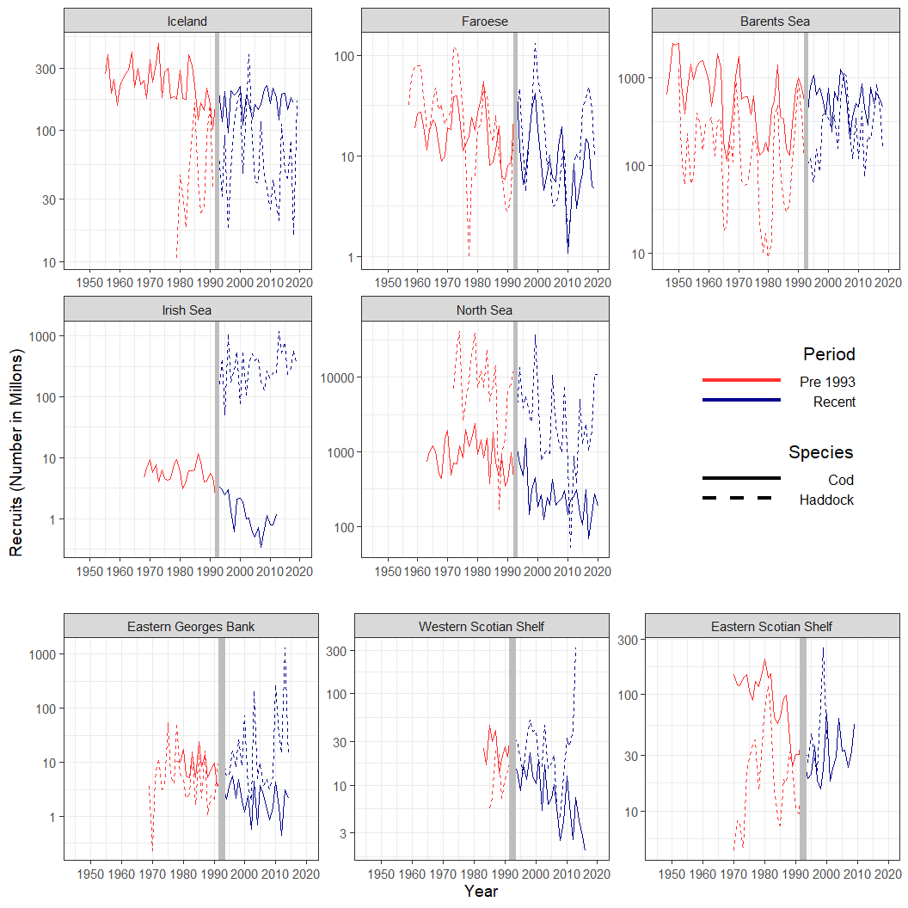

*Figure 1: Recruitment (in millons) time series for 8 cod (solid line) and haddock (dashed line) stocks in the Atlantic Ocean. The red line indicates data from the Pre-1993 Period, while the blue line is for the Recent Period. The vertical grey line indicates the division between the two periods.*

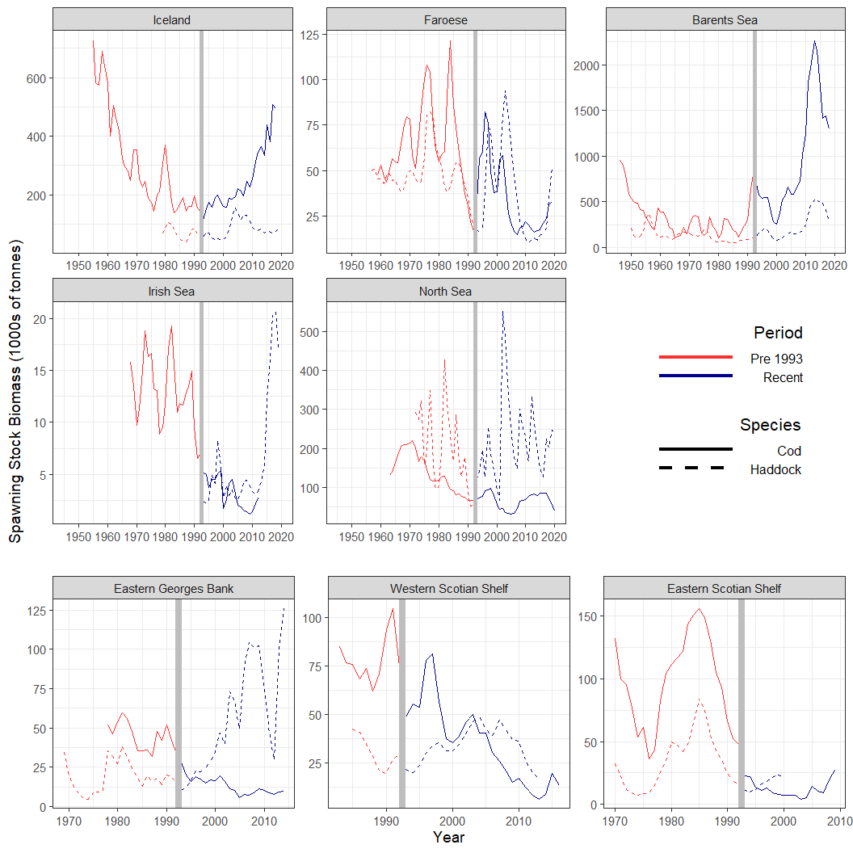

*Figure 2: SSB (thousands of tonnes) time series for 8 cod (solid line) and haddock (dashed line) stocks in the Atlantic Ocean. The red line indicates data from the Pre-1993 Period, while the blue line is for the Recent Period. The vertical grey line indicates the division between the two periods*

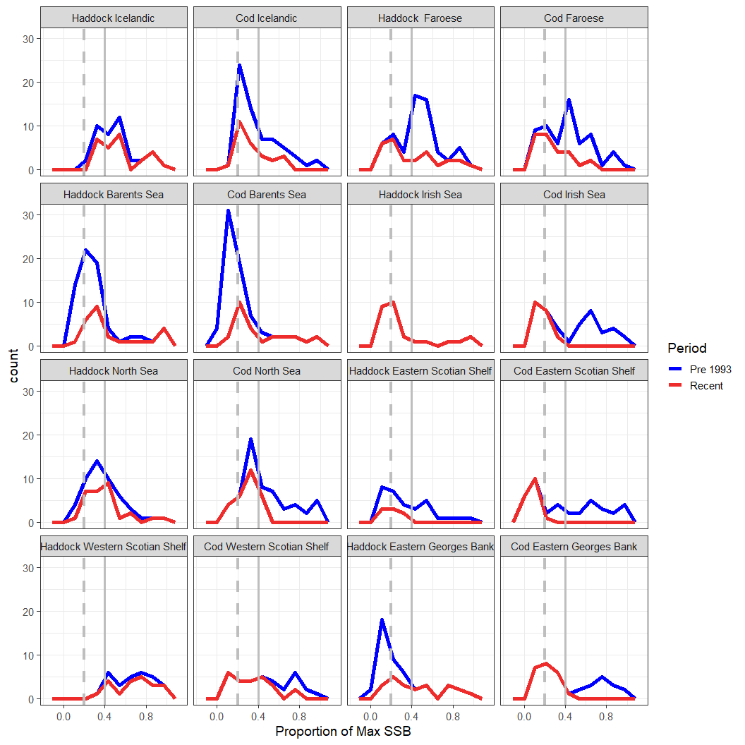

*Figure 3: Density plots of the SSB values by each period. Vertical grey dashed line is the SSB of 0.2 while the grey solid vertical line is 0.4.*

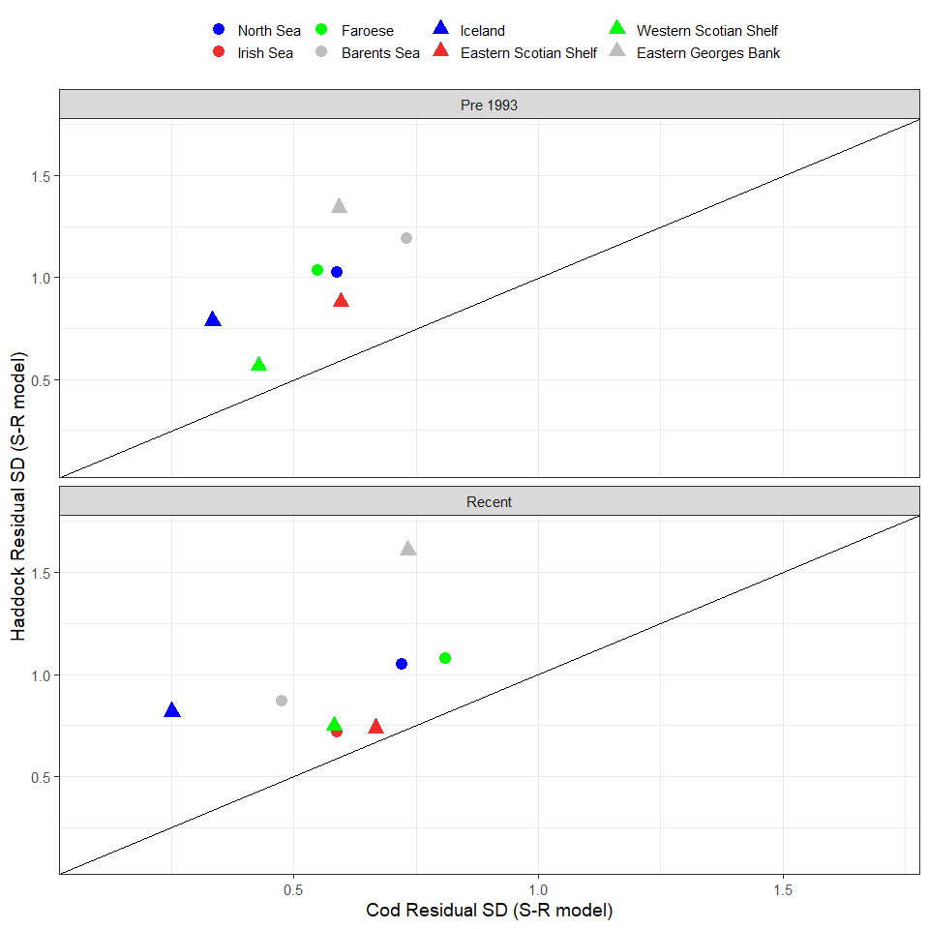

Figure 4: Standard deviation of the log residuals from the Ricker S-R Model

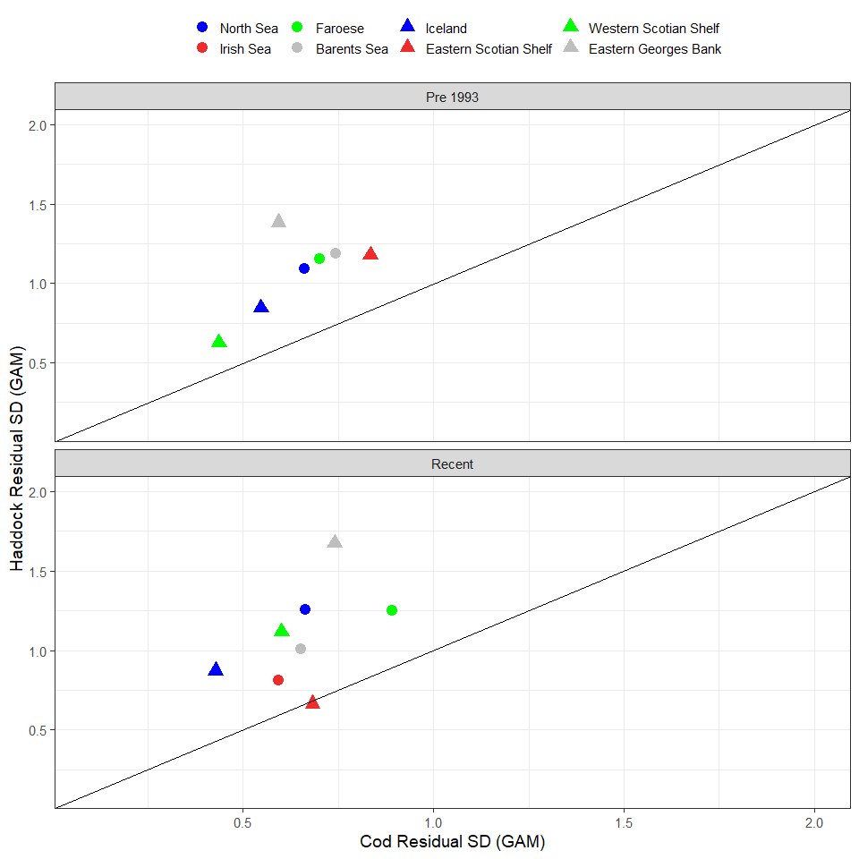

Figure 5: Standard deviation of the log residuals from the GAMs

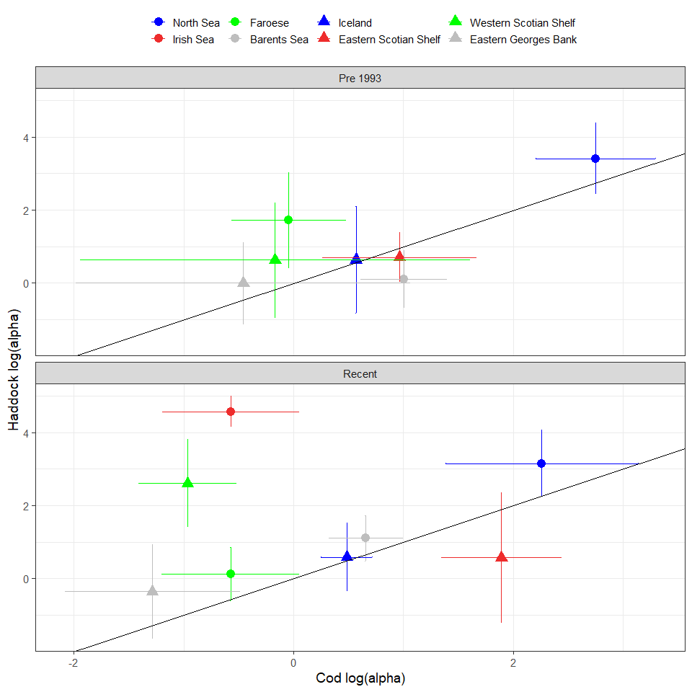

Figure 6: Estimated log(alpha) (as an index of Steepness) from Ricker Stock Recruitment models for each stock in the Pre-1993 and Recent period.

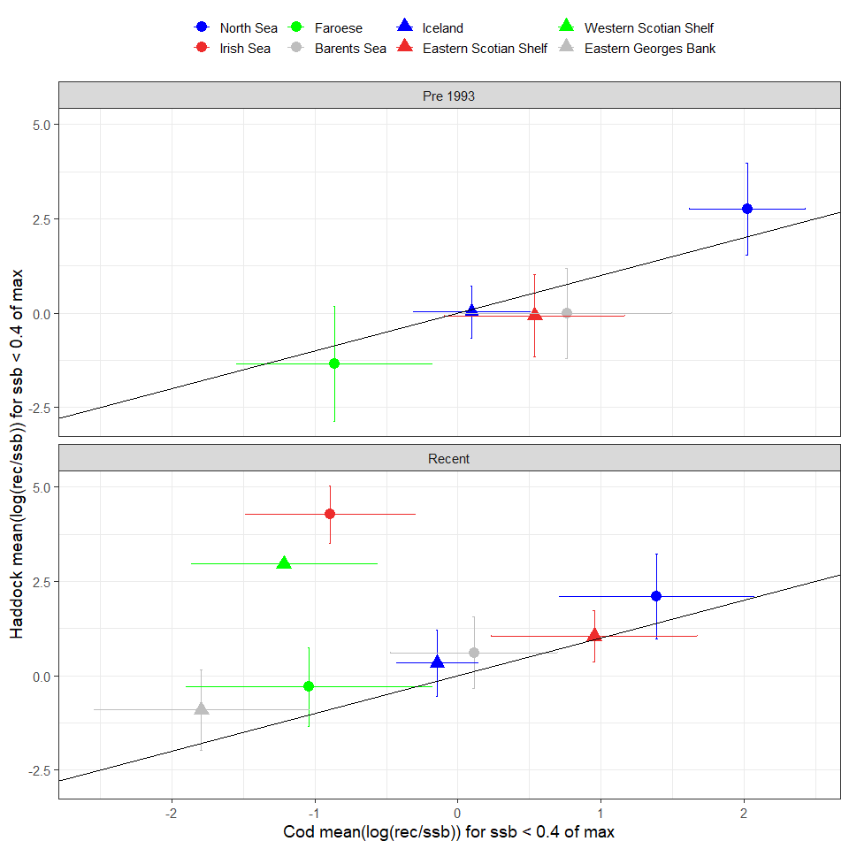

Figure 7: The mean log(Rec/SSB) when SSB is <= 0.4 of maximum ssb

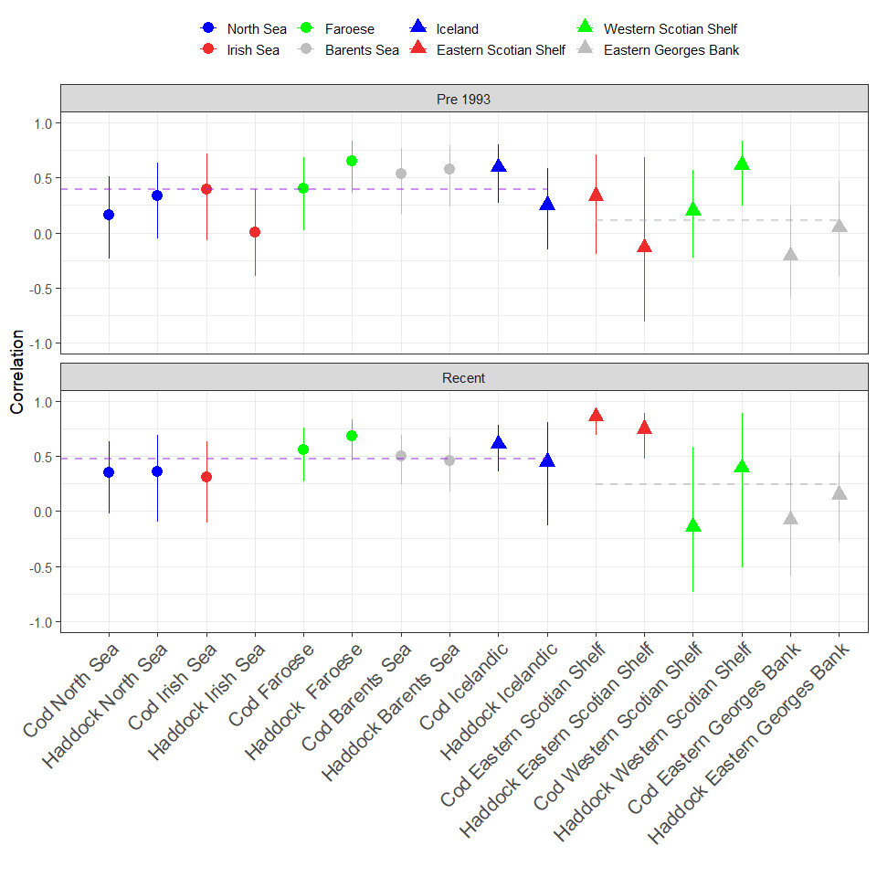

Figure 8: Autocorrelation of recruitment residuals from GAMs in each Period. The dashed lines show the average for the North East Atlantic (left) and North West Atlantic (right) stocks.

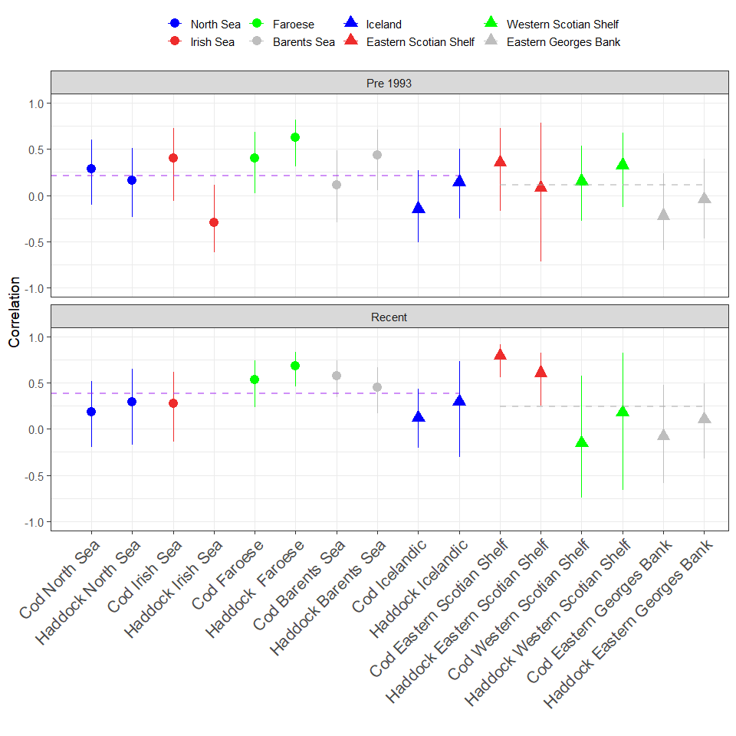

Figure 9: Autocorrelation of recruitment residuals from Ricker Stock Recruitment models in each Period. The dashed lines show the average for the North East Atlantic (left) and North West Atlantic (right) stocks.

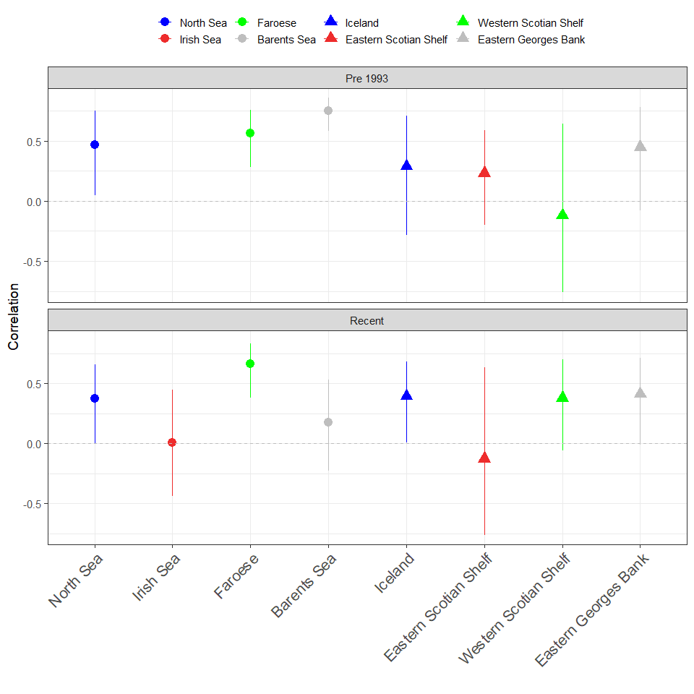

Figure 10: Correlation of the recruitment (log scale) time series between the Cod and Haddock stocks in each Region The dashed lines show the average for the North East Atlantic (left) and